Calculation Policy: Multiplication
Key language: double, times, multiplied by, product, groups of, lots of, equal groups, arrays, factor, multiple
Key representations: place value counters, base 10, bead strings, multilink, counters, Numicon, bar model, number line
Concrete | Pictorial | Abstract
Equal groups:  3 x 4 = 12  4 + 4 + 4 = 12  ‘There are 3 equal groups with 4 in each group’  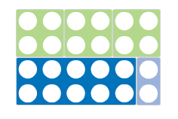 | 3 x 4 = 12  4 + 4 + 4 = 12  ‘There are 3 equal groups with 4 in each group’  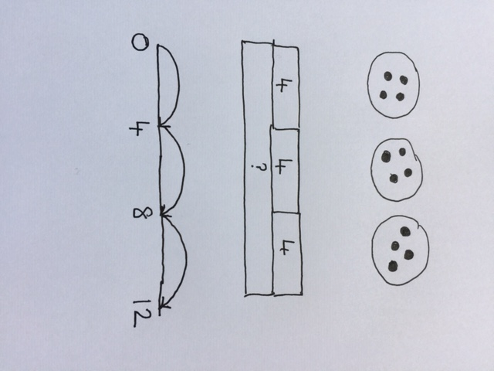 | 3 x 4 = 12  4 + 4 + 4 = 12
Arrays to show commutativity:  3 x 4 = 4 x 3  4 + 4 + 4 = 3 + 3 + 3 + 3  =  3 groups of 4 = 4 groups of 3 | 3 x 4 = 4 x 3  4 + 4 + 4 = 3 + 3 + 3 + 3  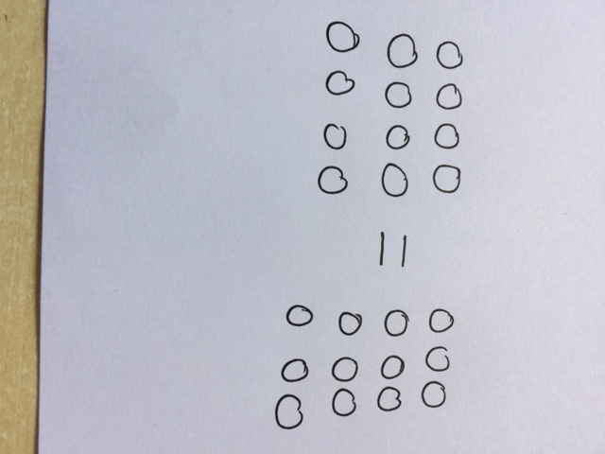 | 3 x 4 = 4 x 3  4 + 4 + 4 = 3 + 3 + 3 + 3
Partition to multiply:  3 x 15 =  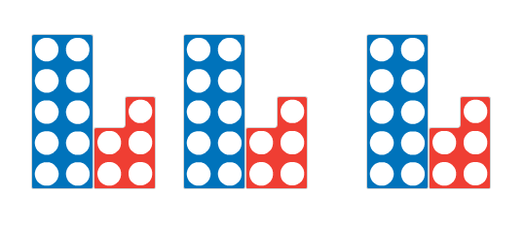  becomes  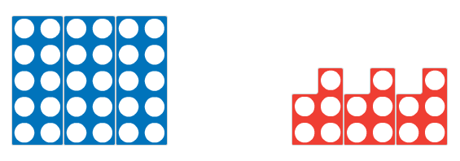  +  3 x 10 + 3 x 5 | 3 x 15 =  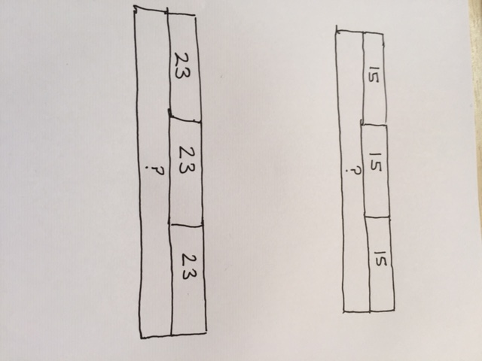  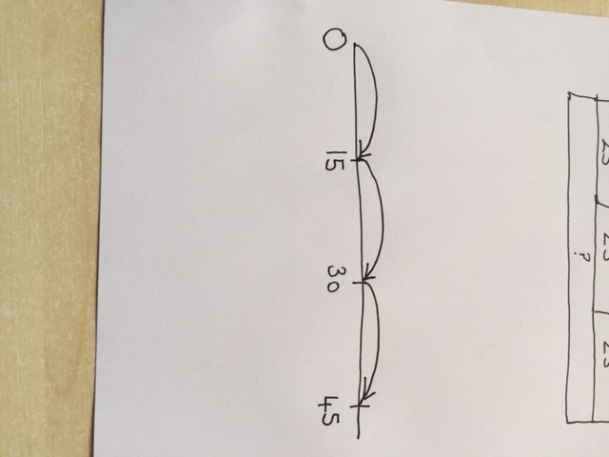 | 3 x 15 =  3 x 10 = 30  3 x 5 = 15  30 + 15 = 45
  x | 10 | 5
  3 | 30 | 15

Short multiplication: 2 digit by 1 digit  23 x 3 =  10s 1s  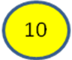  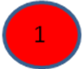  60 + 9 | 23 x 3 = | 23 x 3 =  23  x 3  69
Long multiplication: 3 digit by 2 digit |  | 124 x 26 =  