Calculation Policy: Division
Key language: share, group, divide, divided by, half, equal, dividend, divisor, quotient, factor, multiple
Key representations: place value counters, base 10, bead strings, multilink, counters, Numicon, bar model, number line
Concrete | Pictorial | Abstract
Sharing: using a range of concrete objects  6 ÷ 2 = 3  ‘6 shared into 2 equal groups’  The answer is how many is in each group | 6 ÷ 2 = 3  ‘6 shared into 2 equal groups’  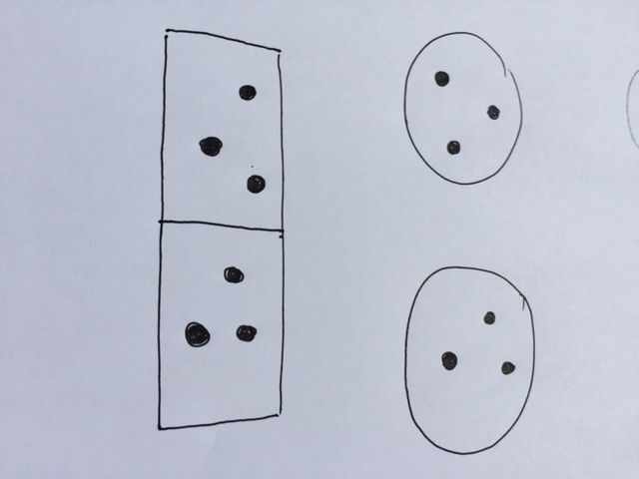 | 6 ÷ 2 = 3  ‘There are 3 counters in each group’
Grouping: using a range of concrete objects  6 ÷ 2 = 3  ‘How many groups of 2 are there in 6?’  The answer is how many groups there are | 6 ÷ 2 = 3  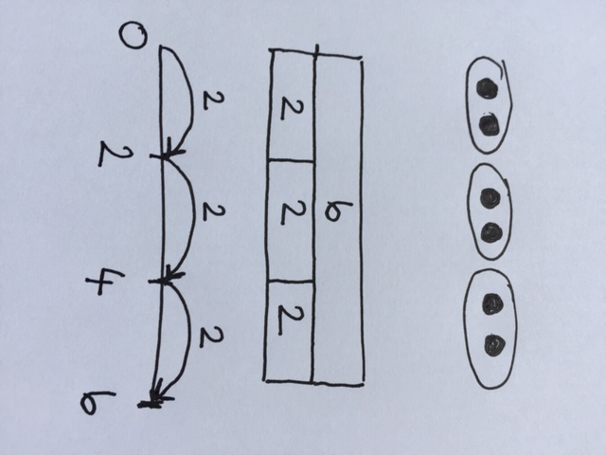  ‘How many groups of 2 are there in 6?’ | 6 ÷ 2 = 3  ‘There are 3 groups of 2 in 6’
Grouping: with remainders  13 ÷ 4 =  ‘How many groups of 4 are there in 13?’  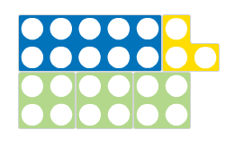  There are 3 groups of 4 and 1 left over/remainder | 13 ÷ 4 =  ‘How many groups of 4 are there in 13?’  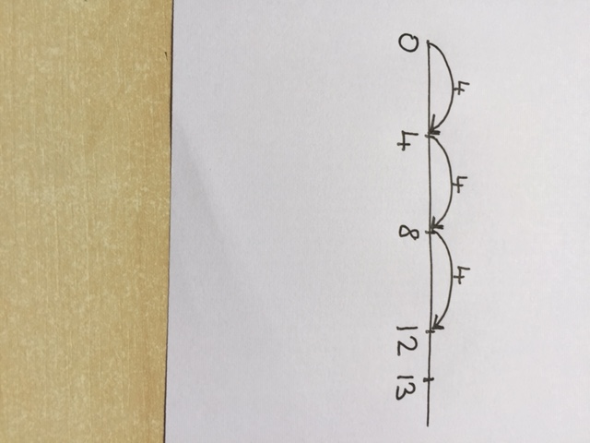  There are 3 groups of 4 and 1 left over/remainder | 13 ÷ 4 = 3 r 1  ‘There are 3 groups of 4 and 1 remainder’  ‘3 remainder 1’

Short division: 2 digit by 1 digit (with no exchange)  (Only use when the dividend is beyond the twelfth multiple. Before the twelfth multiple, times tables facts should be used).  84 ÷ 4 = 4 84  10s 1s  2  1  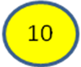  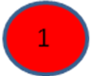  4  How many groups of 4 are there in the tens column?  There are 2 groups of 4 in the tens column.  How many groups of 4 are there in the ones column?  There is 1 group of 4 in the ones column.  There are 21 groups of 4 in 84 | 84 ÷ 4 = 4 84  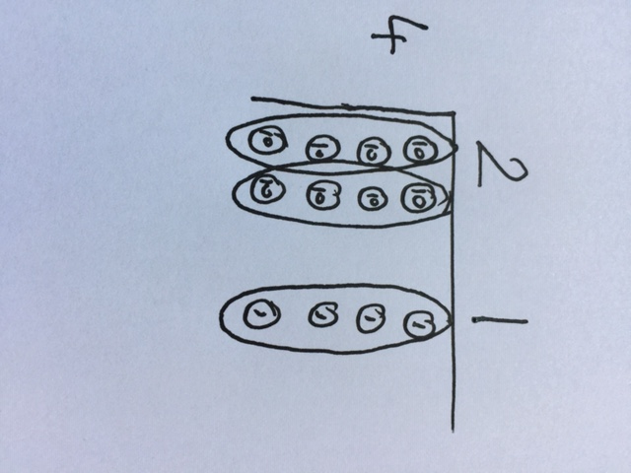  10s 1s  How many groups of 4 are there in the tens column?  There are 2 groups of 4 in the tens column.  How many groups of 4 are there in the ones column?  There is 1 group of 4 in the ones column.  There are 21 groups of 4 in 84 | 10s 1s  2 1  84 ÷ 4 = 21 4 8 4
Short division: 2 digit by 1 digit (with exchange)  (Only use when the dividend is beyond the twelfth multiple. Before the twelfth multiple, times tables facts should be used).  342 ÷ 3 = 3 342  100s 10s 1s  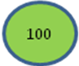  3  How many groups of 3 are there in the hundreds column?  There is 1 group of 3 in the hundreds column  How many groups of 3 are there in the tens column?  There is 1 group of 3 and 1 ten left over so I need to exchange 1 ten for 10 ones  100s 10s 1s  1 1 4  3  How many groups of 3 are there in the ones column?  There are 4 group of 3 in the ones column  There are 114 groups of 3 in 342 | 342 ÷ 3 = 3 342  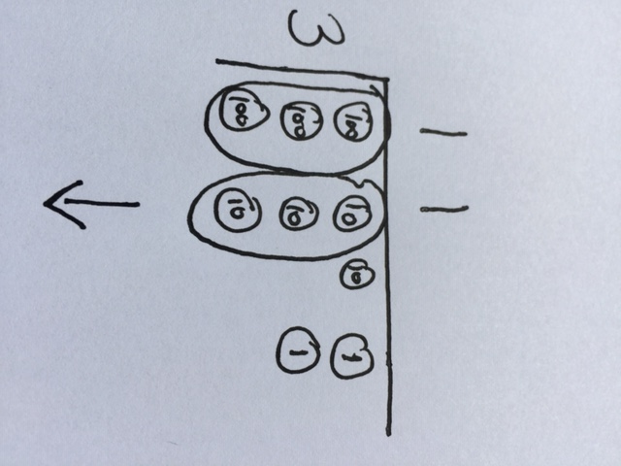  100s 10s 1s  100s 10s 1s  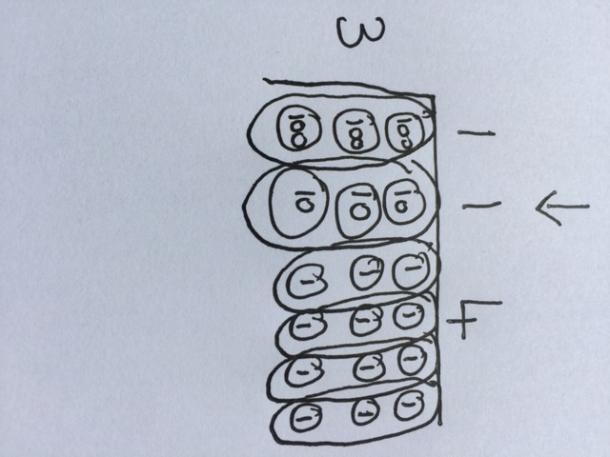 | 342 ÷ 3 = 114  100s 10s 1s  1 1 4  1  3 3 4 2
Long division: 3 digit by 2 digit |  | 615 ÷ 15 =  Write a list of multiples of 15 e.g. 15, 30, 45, 60 then use short division  41  1  15 61 5

